# INTRODUCTION

* 1. Overview

CRM (Customer Relationship Management) applications for Retail Management are software systems designed to help warehouses to maintain the stocks availability and products. These applications allows us to collect and analyze data about the product for the maintenance of stocks availability.

* 1. Purpose

Customer Relationship Management (CRM) applications for Retail Management serve the purpose of monitoring stock availability directly by the owner. These applications lets us to store customer and prospect contact information, Identify Sales Opportunities.

1. **Problem Definition & Design Thinking**
   1. 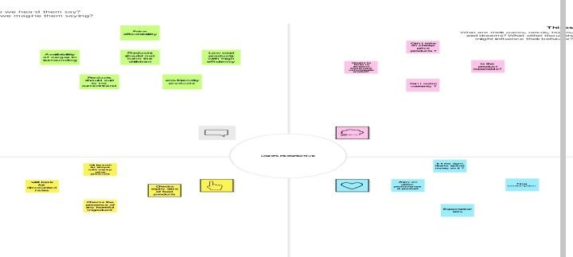Empathy Map
   2. Ideation & Brainstorming Map

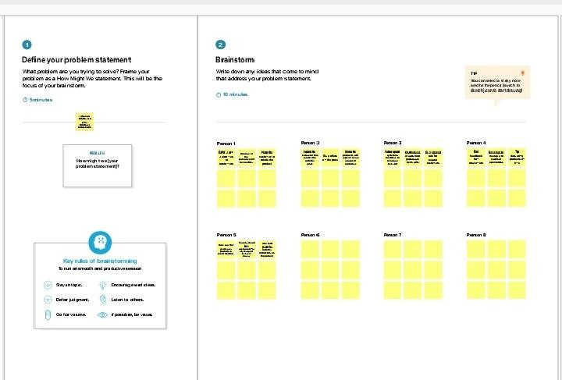

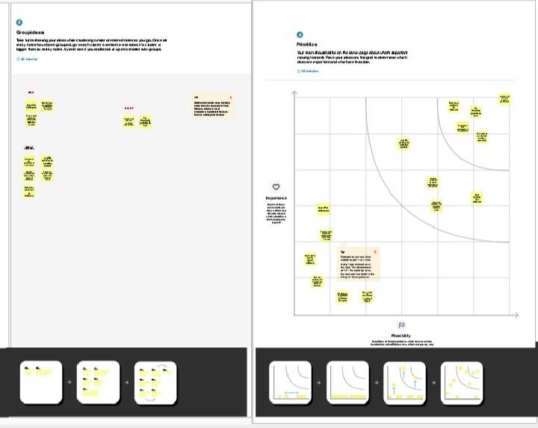

# RESULT

* 1. DataModel:

|  |  |
| --- | --- |
|  |  |
|  |  |
|  |  |
|  |  |
|  |  |
|  |  |

|  |  |  |  |  |
| --- | --- | --- | --- | --- |
| Object name | Fields | in | the | Object |
| Dispatch/Tracking |  |  | | |
|  | Field Label | Data type | | |
|  | Dispatched | Checkbox | | |
|  | Expected Date of Delivery | Checkbox | | |
|  | Tracking Id | Checkbox | | |
|  | Sales order | Checkbox | | |

# Activity&Screenshot

MILE STONE 1-OBJECT CREATION

# Dispatch/Tracking:

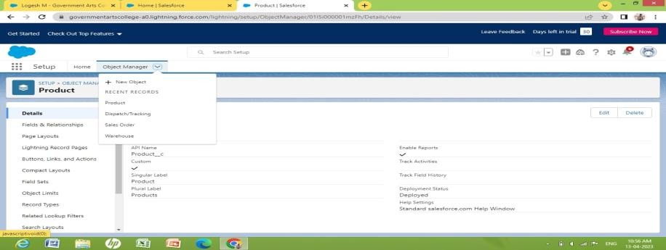

**MILE STONE 2 - Creation fields on Dispatch/Tracking: MILESTONE 3 - Activity 1:**

# Creation of relationships between objects:

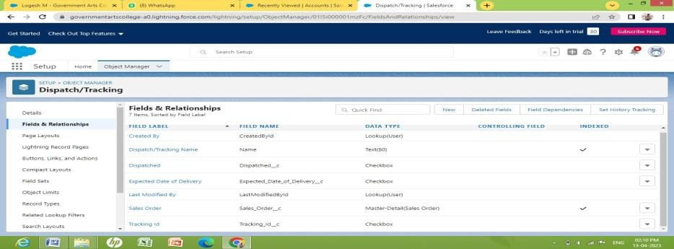

**MILE STONE 4: ACITIVITY-1**

# Creation of Application:

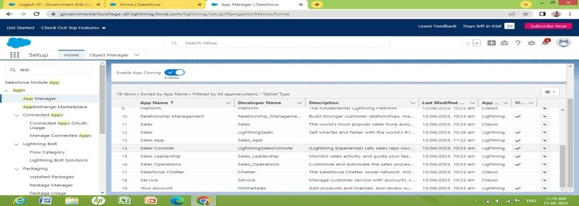

**MILE STONE 5: LAYOUTS ACITIVITY-1**

# Creation of custom tabs

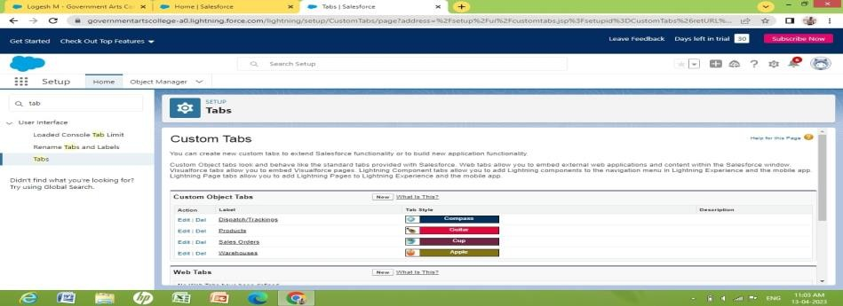

**MILE STONE 6: USER**

# Activity -1 Creation of user

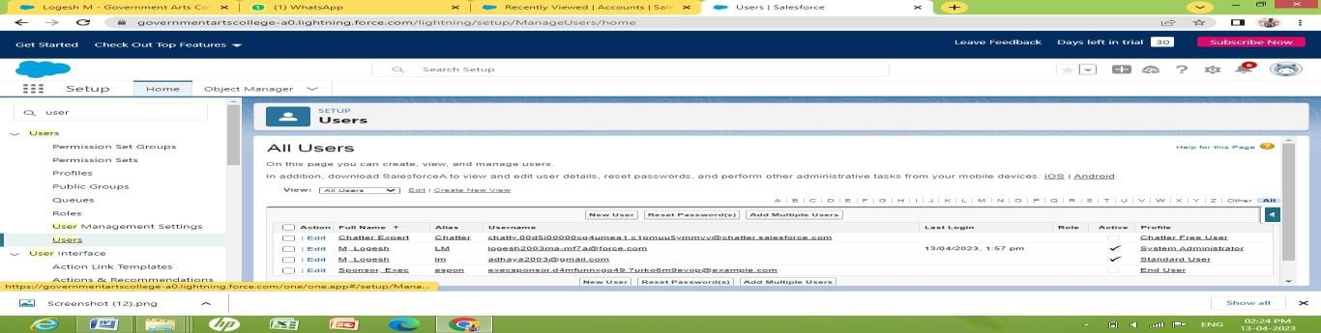

MILE STONE 7:

Activity 1:

Creation of validation rules:

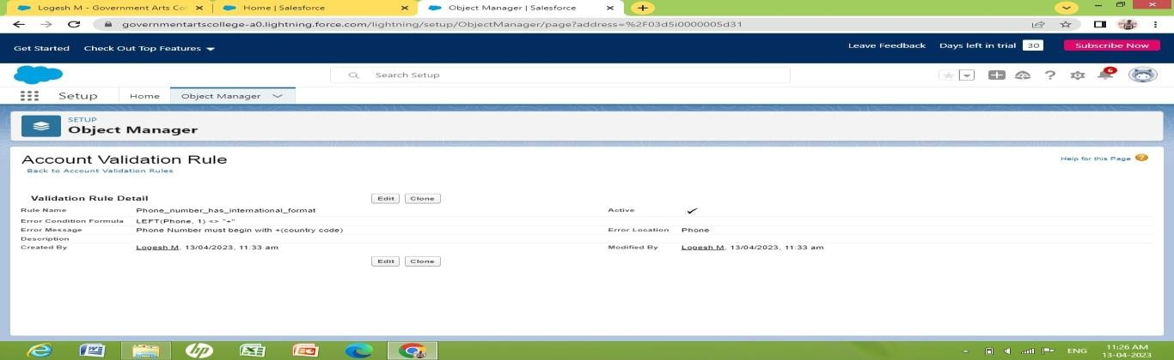

# Activity-2 :Cross Object Formula

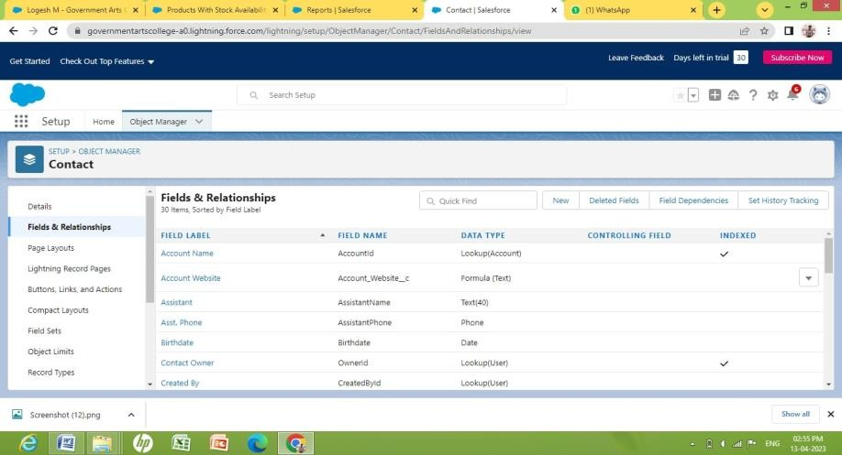

**MILE STONE 7:REPORTS**

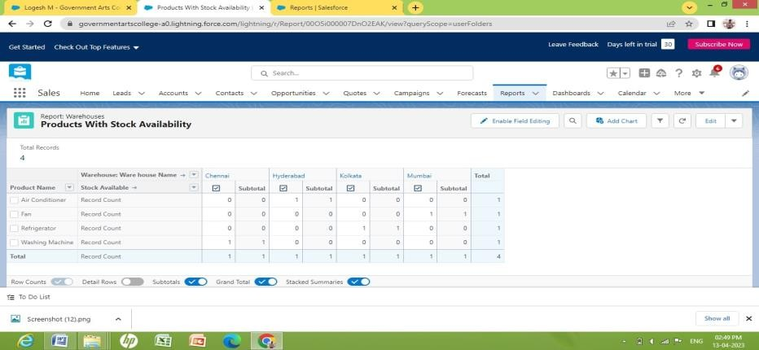

# MILE STONE 8 : DASHBOARD

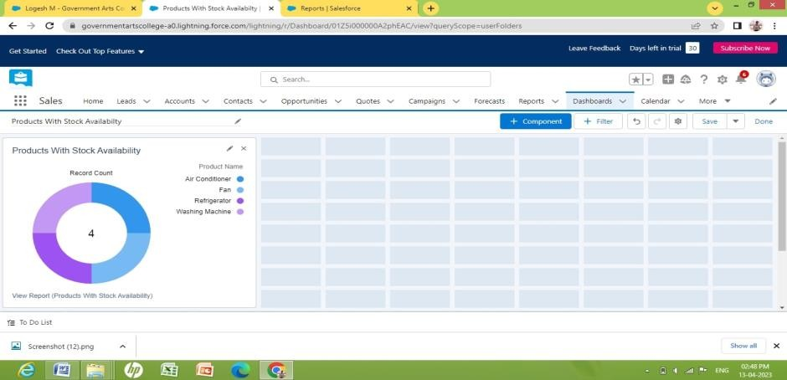

1. **Trailhead Profile Public URL**

# 1.FRANCIS M -(TEAM LEAD)

# https://trailblazer.me/id/fcreation2

**2.RAJADURAI S –**

[**http://trailblazer.me/id/rajas309**](http://trailblazer.me/id/rajas309)

**3.GOBINATH G –**

**https://trailblazer.me/id/griyo**

**4.ANANDHA KUMAR E –**

**https://trailblazer.me/id/anandhakumare**

# 4 ADVANTAGES

* Improved Stock Maintenance
* Streamlined Processes
* Data Analytics
* Liability on products to customers

# DISADVANTAGES

* + Cost
  + Complexity
  + Data privacy
  + Resistance to change
  + Overemphasis on metrics
  + Risk of data silos

# APPLICATION

* + Stock Maintenance
  + Customer Database
  + Product Availability
  + Warehouse Maintenance
  + New stocks Management

# CONCLUSION

CRM applications for retail management provides good relationship between customers and service providers.As the customers and service providers are meeting in person, they can understand each other' needs and look for products of their prefererce. This will help service providers to retail customers.This application helps customers to collect good produts on their own needs.The customers need not wait for the products to arrive at their home as in onaline selling.This helps the owners of the warehouse to directly check the stock availability. It Quickly generates the salesorder receipts and helps service providers to have complete picture of stock and product Availability in the different types of charts in dashbord.

# FUTURESCOPS

The scope of CRM includes a wide range of activities, from managing customer contact information to developing personalized marketing campaigns. In order to be effective, CRM must be tailored to the specific needs of each business. As such, the scope of CRM can vary greatly from one company to the next. It becomes ease of access to go through all tabs like reports and dashboard for the updation in the stock and product Availability.